The following documentation is a pictorial guide of how to make and how to review a pull request.

Making a Pull Request

Select the pull request tab

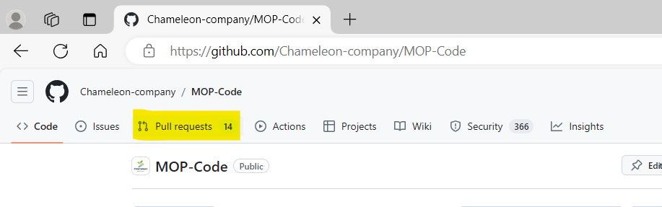

Select open new pull request
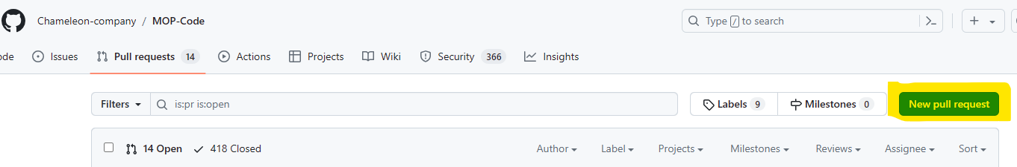

Select your branch from the drop down list in “compare”

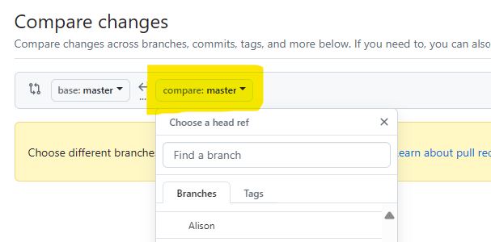

Select “create pull request”

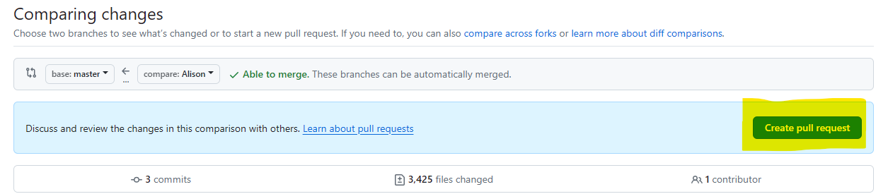

Add title and description for your pull request
Title must include which team you are (DATA SCIENCE or WEBDEV)
Name of what you are working on (This should match what is on your Trello card)
Percentage of completion of your use case from Trello
Description must include reason for pull, e.g. use case completed, Sprint 1 pull request.
Description must include a list of the changes that have been made to your folder since last making a pull request.

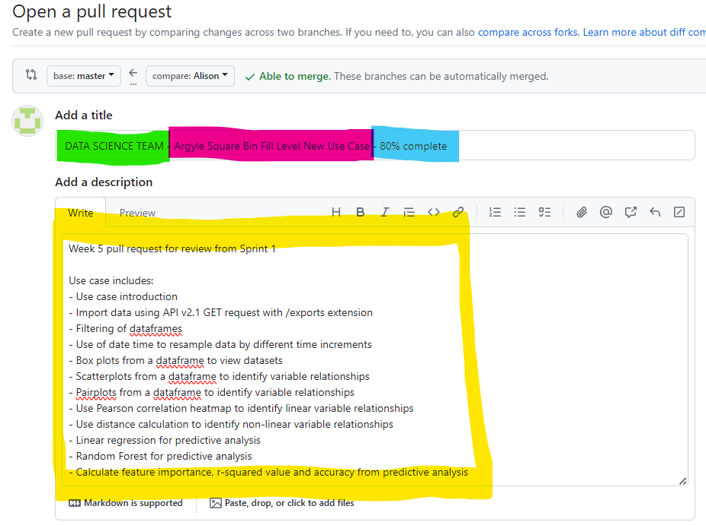

Select reviewers and choose 2 reviewers
One reviewer can be any member of your team, the other MUST be a leadership student.
You should message students fist to check if they are happy to review for you. You can find a list of GitHub user names to add reviewers on the Melbourne Open Playground team list in Teams.

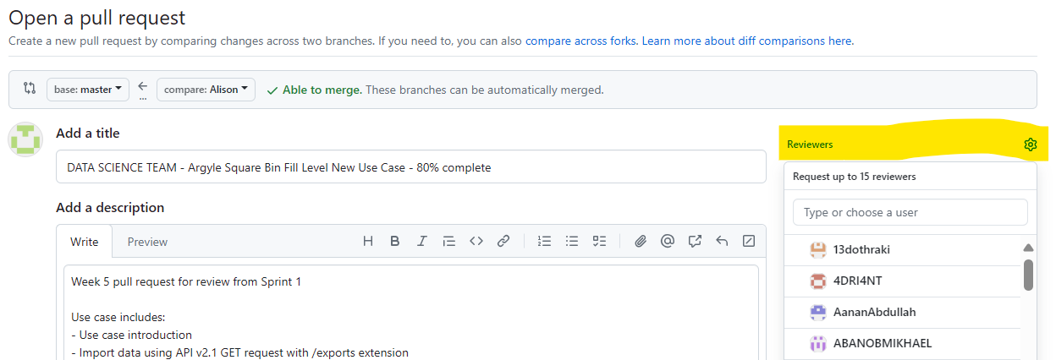

Check you have added two reviewers
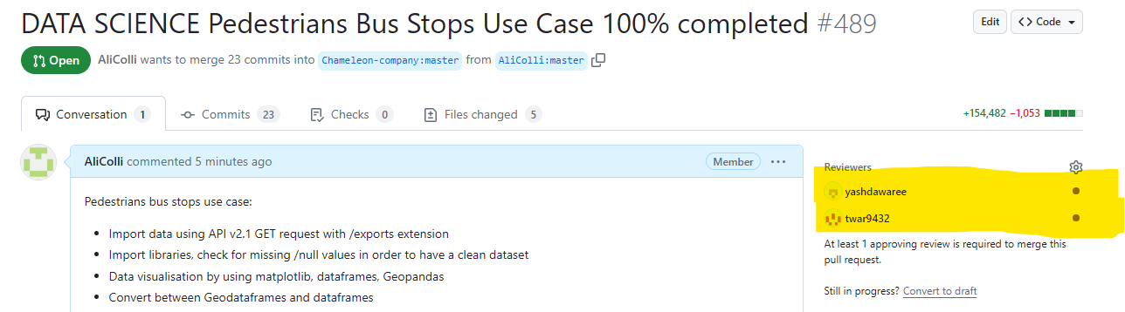

Create your pull request
Create your pull request by pressing the green “create pull request” button
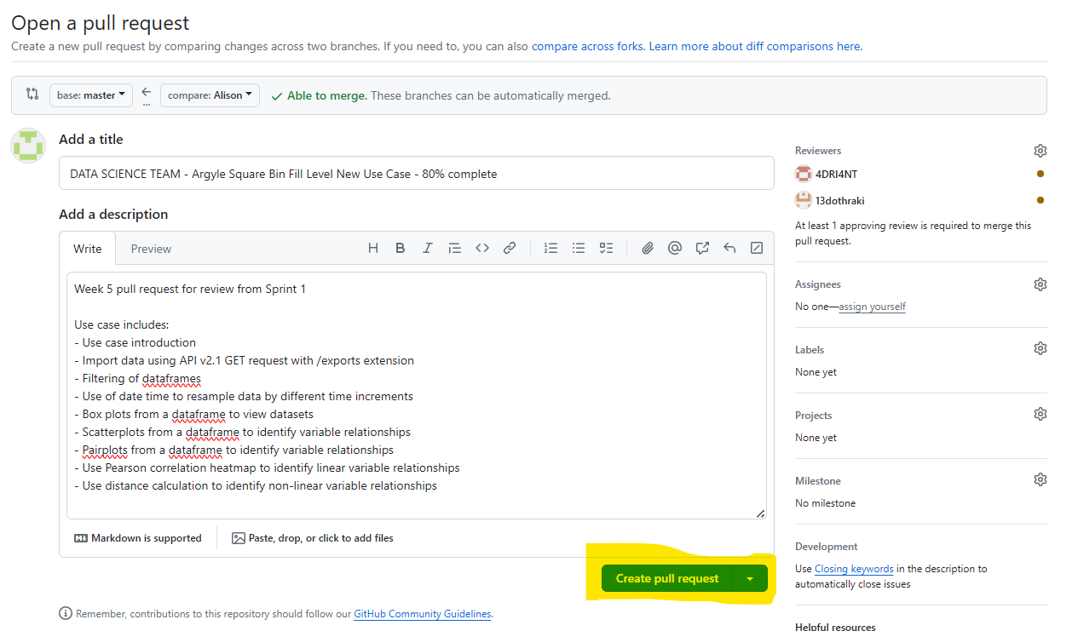

After Making a Pull Request

Check your emails
You will be emailed when your pull request receives comments or approvals.
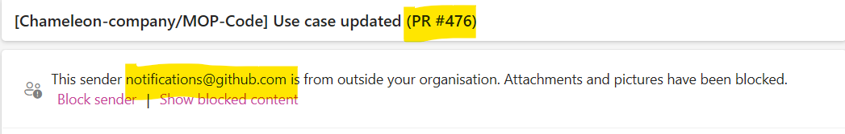

Check GitHub Conversation for Feedback
After reviewing, your team members will leave you feedback in GitHub.
Open your pull request, and scroll down to the comments section to see this. If you need to make changes you will need to do so in your IDE and then push to GitHub again.
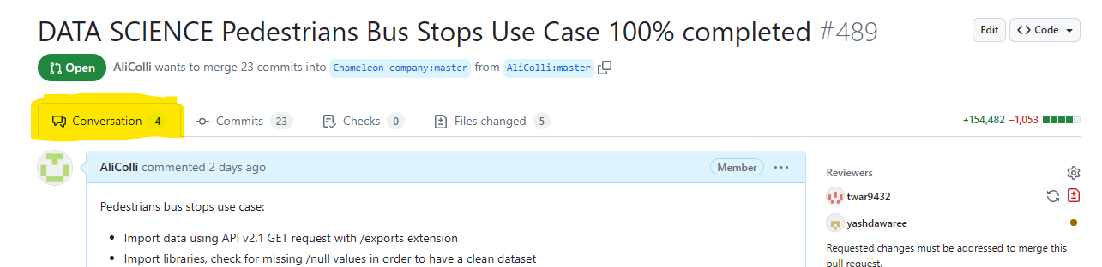
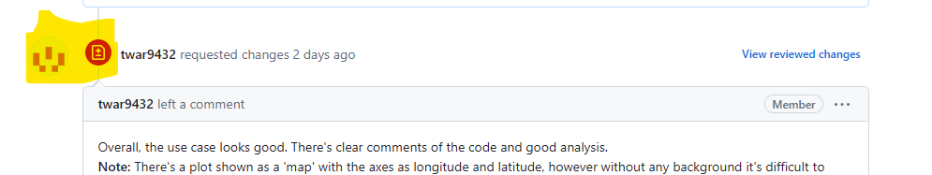

After making changes
Once you have updated your code and pushed again you will see a new comment automatically generated
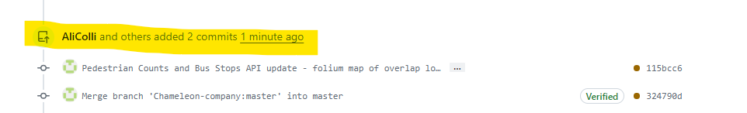

You will need to also add a comment to email your reviewers so that they know you have updates your work and that it is ready to be re-reviewed.
Be sure to write @ next to their GitHub name so they receive an email notification.
Be sure to press the green “comment” option to keep your pull request open.
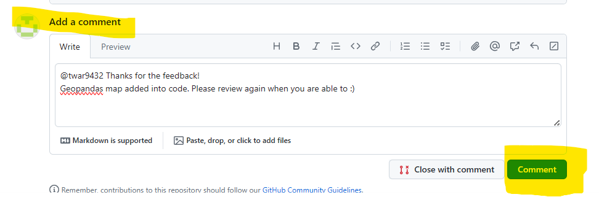

Check review status
Check both reviewers have approved your pull request. Look for green ticks against reviewers names
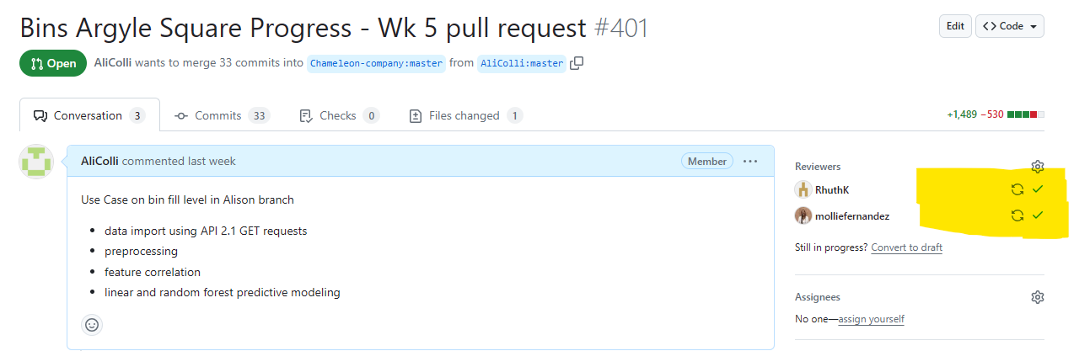

Merge pull request
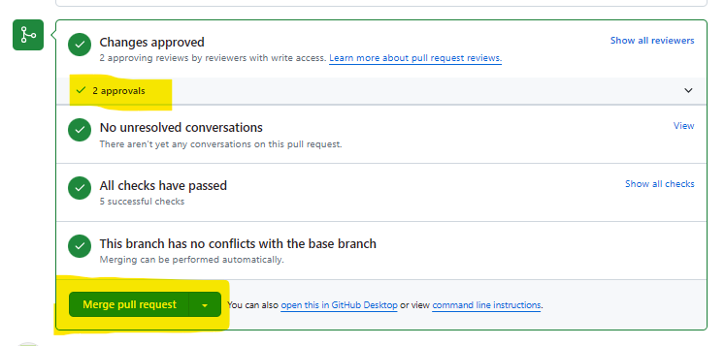
Once you have two approvals, Merge your pull request!

Reviewing a Pull request

View open pull requests
On GitHub, select “Pull requests”
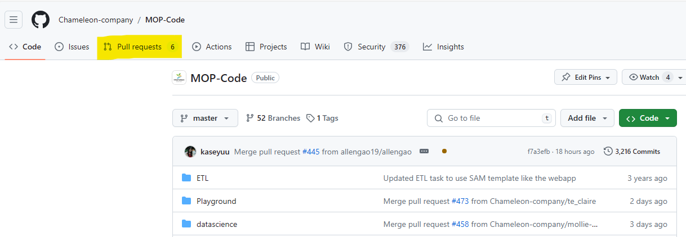

Select a Use Case to review
Select the “Reviews” tab and the “Awaiting review from you”
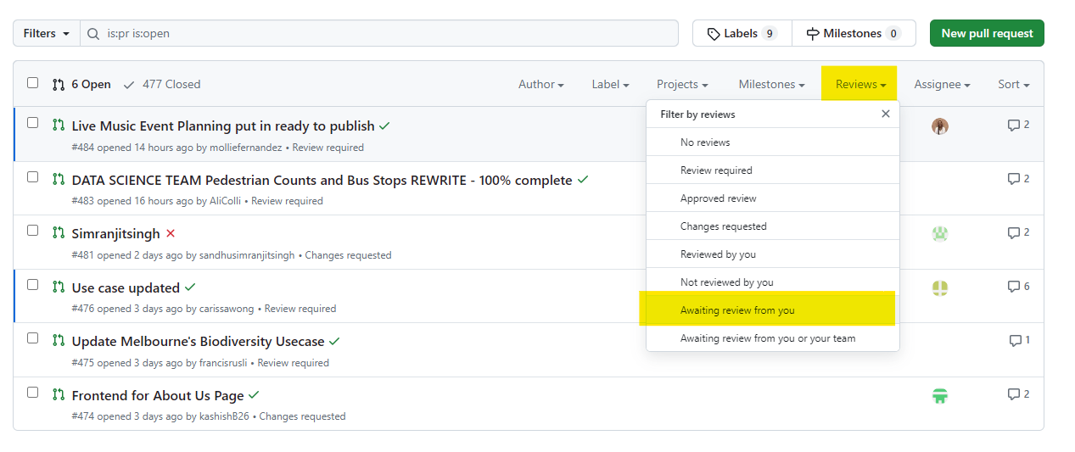

OR

Check your emails for review requests
Follow the link to the use case from your email


View the Use Case
When the use case is open, select the files changed tab. If the use case is large, you will get a load diff alert. In this case, select the three dots on the right hand side and go to view file.
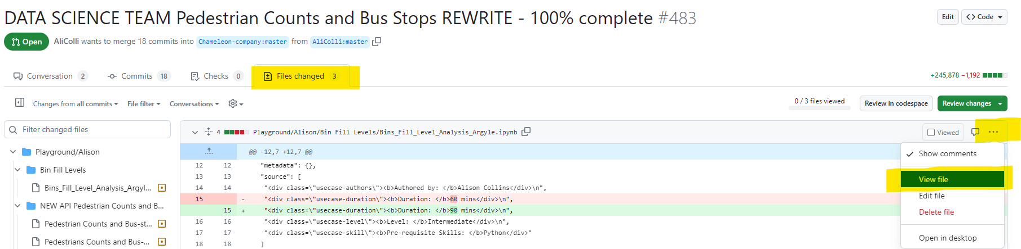

Things to check for in the “Preview” view:
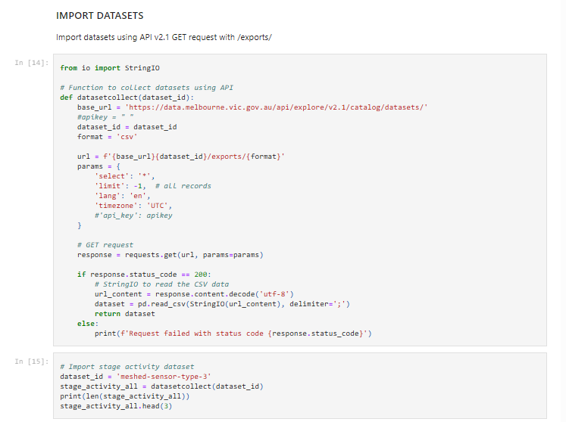
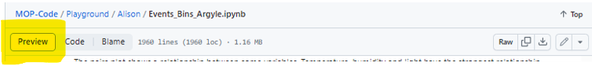

Dataset import
– Must be API v2.1
– API key must NOT be visible

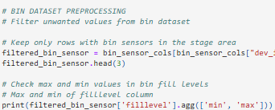
Code sections
– Code must be clear and easily readable
– Comments must have a space and capital letter for first word
– Explain code in a way that can be easily followed

Markdown style, colours in graphs and tables
– Adhere to Chameleon Company requirements
– Details in use Case publishing guide on page 3
MOP-Code/datascience/documentation/Use case publishing guide.pdf at master · Chameleon-company/MOP-Code (github.com)

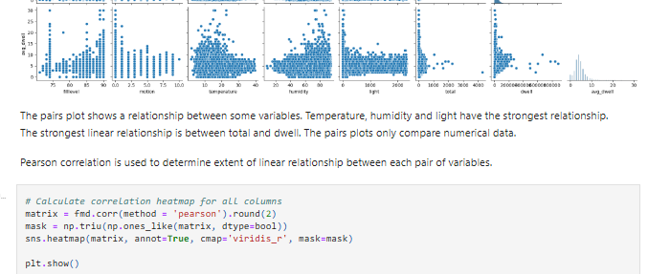
Written explanations
– Reason for methods chosen
– Explanations of output
Remember: the use case is written
to teach people how to do this!
So explanation is important!

Things to check for in the “Code” view:
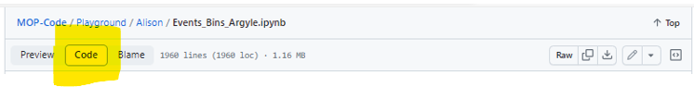
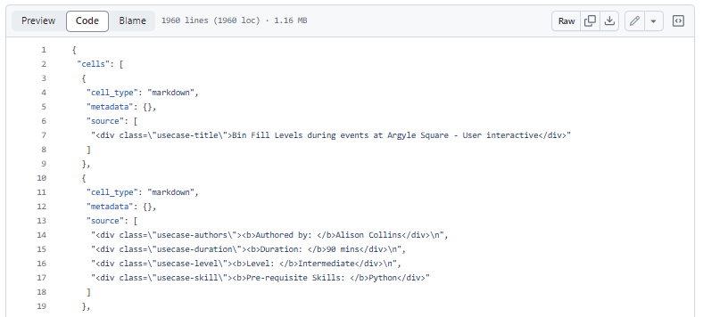
HTML in code
– HTML as per usecase TEMPLATE

Troubleshooting viewing:

If the Use Case or parts of it (graphs, tables, folium maps) will not render on GitHub, copy the link from the GitHub and open in https://nbviewer.org/

Select the files changed tab, three dots on the right and then view file
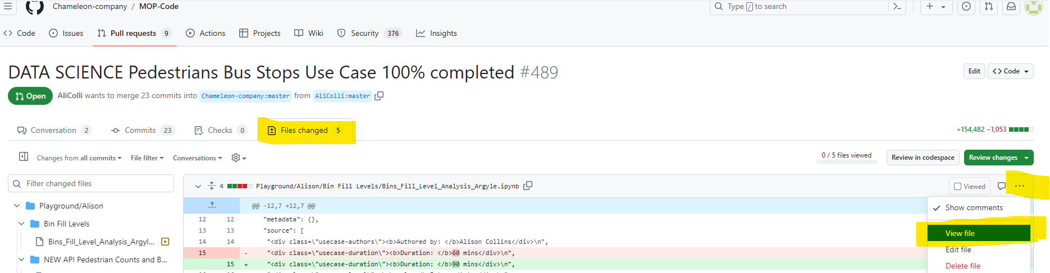

Copy the address bar
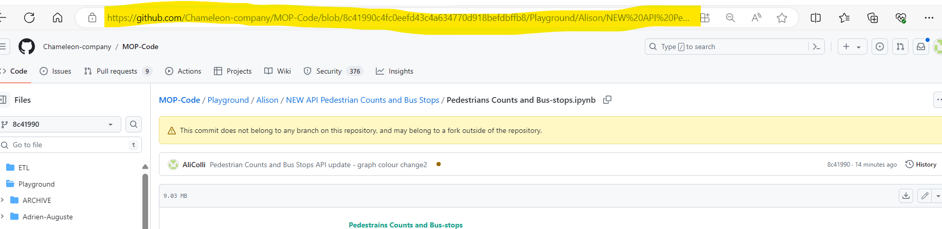

Paste into https://nbviewer.org/ and press go
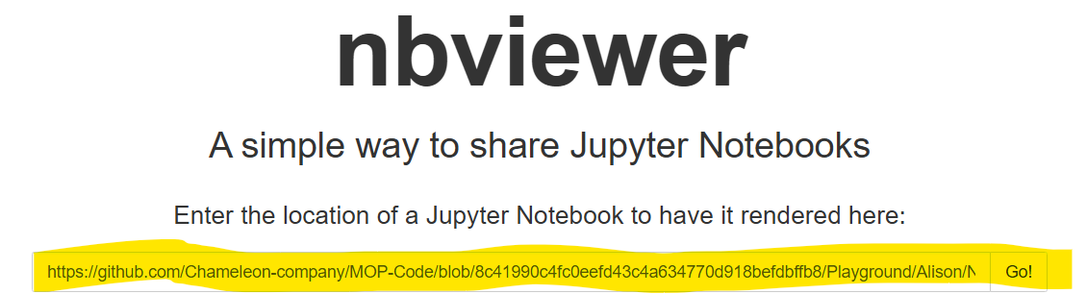

Further reading
Capstone Pull Requests: 5. Navigating Pull Requests on GitHub | Capstone (verdant-raindrop-f3e404.netlify.app)
Capstone Reviewing Pull Requests: 6. Reviewing Pull Requests | Capstone (verdant-raindrop-f3e404.netlify.app).

Author
Alison Collins, 2024

